**Touch**

**Typing**

**Class Five**

**Lab 7**

|  |
| --- |
| Lab Objectives:  * Home Keys * Correct Finger Position |

# Touch typing

## Touch typing is a style of typing without looking at the keys.



# Basic of Typing

## The first image below shows the overall keyboard layout for a QWERTY keyboard.

## IMG_256

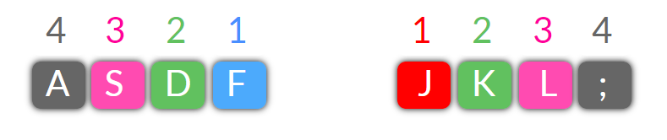

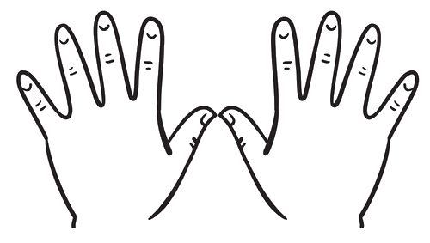

Left Hand Right Hand

## The second image shows the Home Keys for the left and right hand. A S D F on the left and J K L ; on the right.

## They are called the Home Keys because these are the keys your fingers must return HOME to after typing any other key.

# Start Typing

## To learn fast typing you just have to practise more and more. There are not too much theoretical lesson for typing,the one and only rule is to place your finger on the correct position and type.

## IMG_256Place your finger like below

# Practise Session

## Open ms word and type this

### Warm up for left hand

## ffff dddd ssss aaaa ffff dddd ssss aaaa ffff dddd ssss aaaa

## ff dd ss aa ff dd ss aa ff d ff d ff s ff s ff a ff a

## fdsa fdsa fdsa fdsa fdsa fdsa fdsa fdsa

## asdf asdf asdf asdf asdf asdf asdf asdf asdf asdf

### Warm up for right hand

## jj kkk lll ;;; jjj kkk lll ;;; jjj kkk lll ;;;jj kk ll ;; jj kk ll ;;

## jj kk ll ;; jj kk ll ;; jj k jj l jj ; j k l ; j k l ; jjj kkk ll ;;

## jkl; jkl; jkl; jkl; jkl; jkl; jkl; jkl; jkl; jkl; jkl; jkl;

### Both Hands

## ds dsl ld; fs ks; sl lk; lks kj jd; jds ja jak sk; fa la as jf jk js

## ad add ads adds as ask asks la lad lads lass da dad dada dada sa sad salad